AWS Task-4(EBS & EFS & FSx)

Task Description:
Launch an EC2 instance (Linux and Windows) along with a web server. Then, create an EBS volume of 5 GB, attach it to an EC2 machine (Linux and Windows), and take a snapshot. Finally, create an EBS volume using the taken snapshot.

OUTPUT:
Step 1: Launch an EC2 instance (Linux and Windows) with Web server
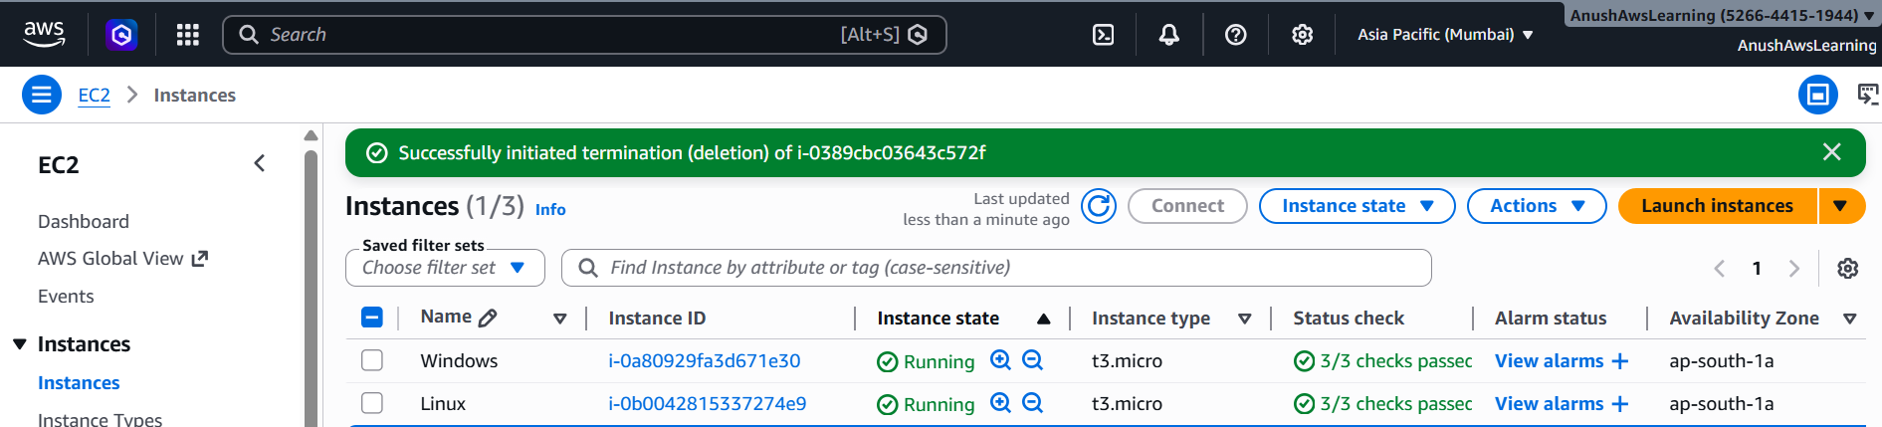

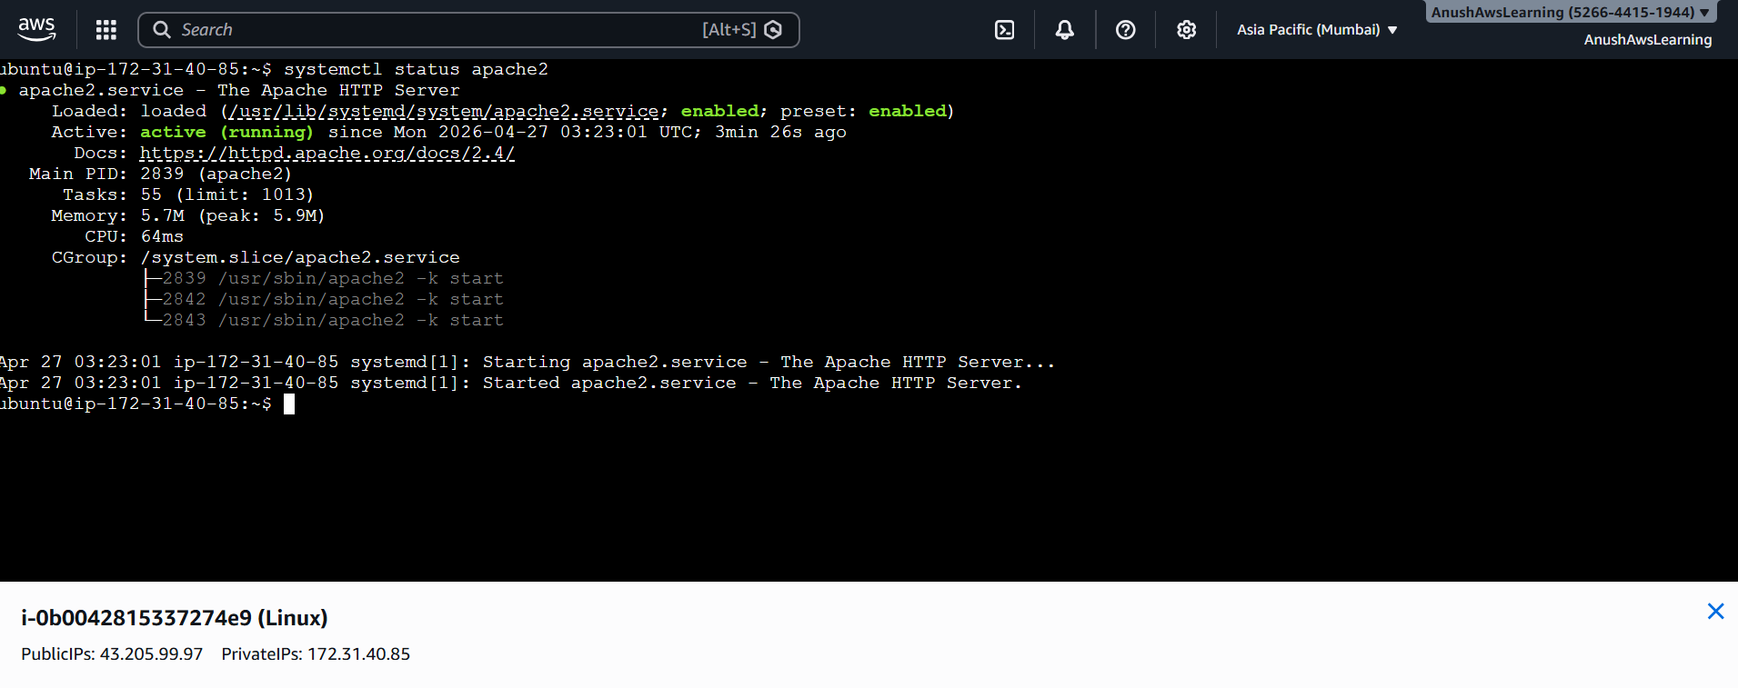

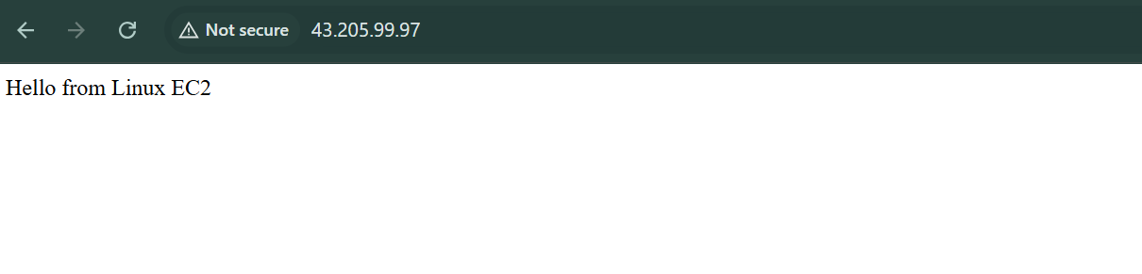
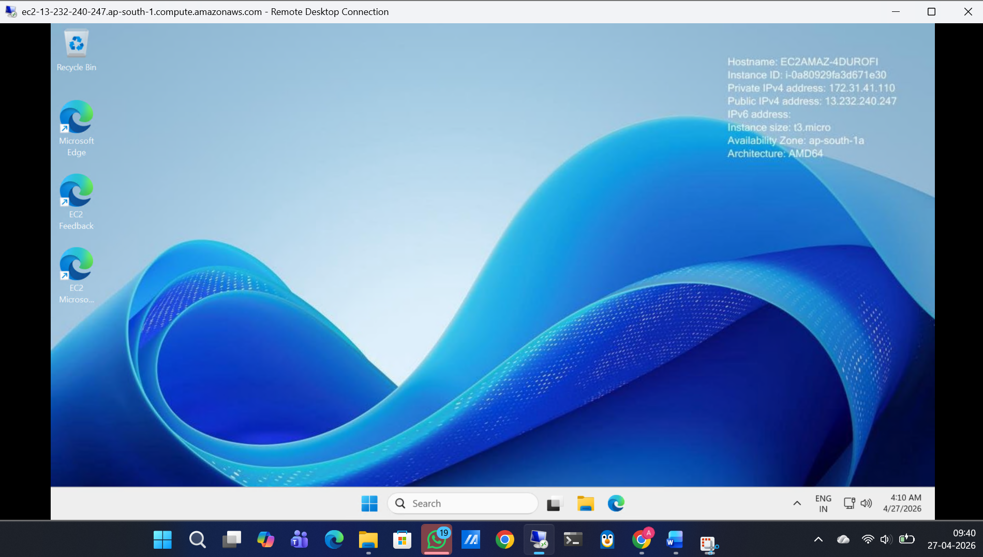
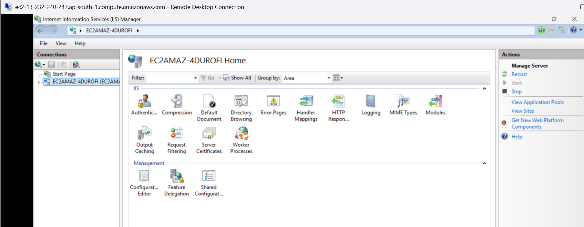
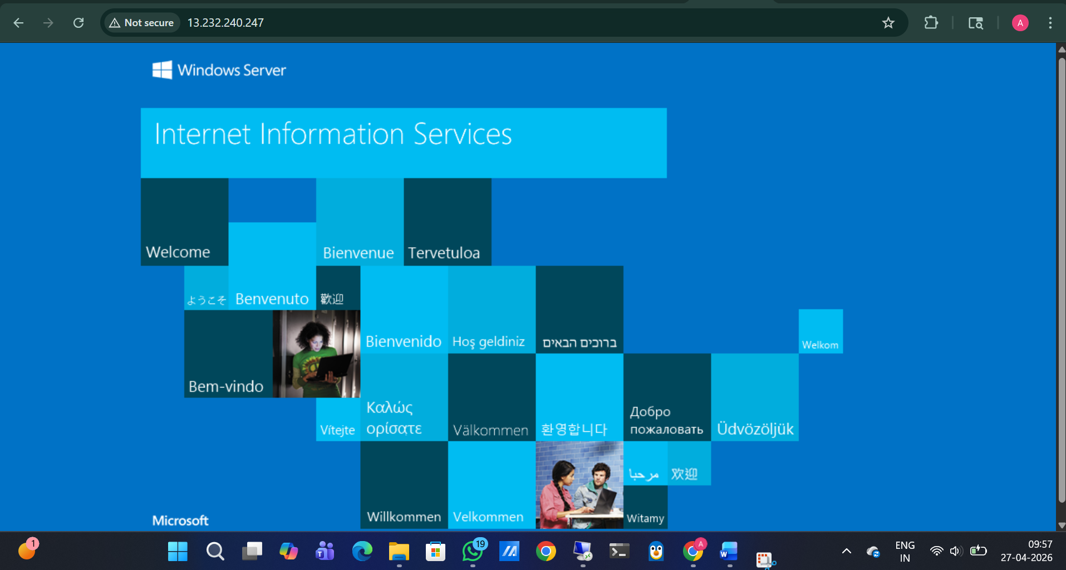

Step 2: create an EBS volume of 5 GB
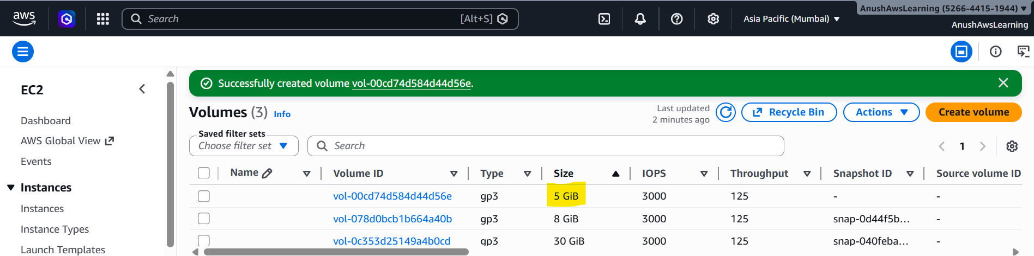

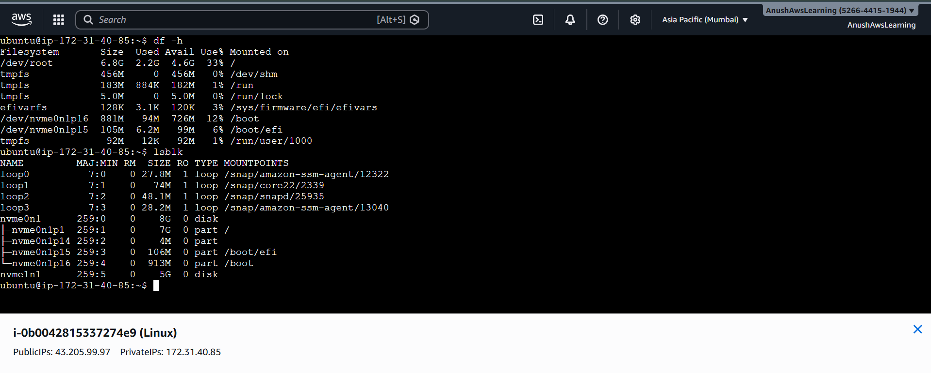
Step 3: Attach Volume to EC2
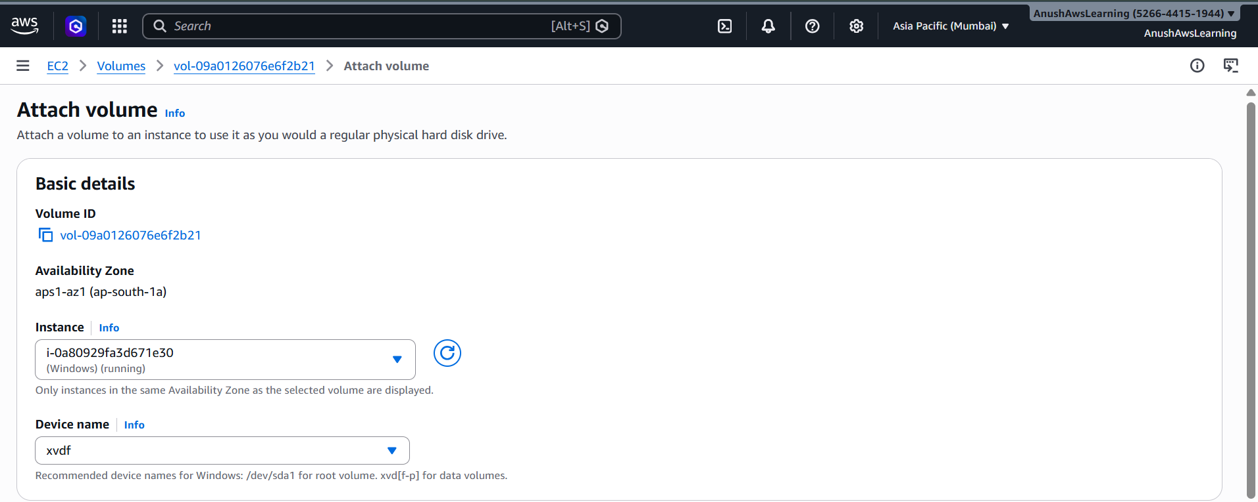
Configure the Volume On Windows Instance
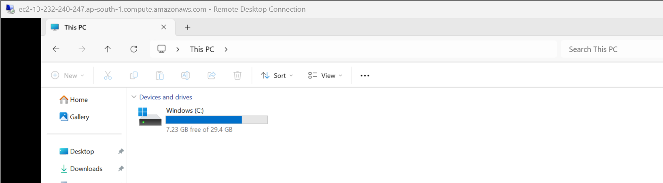
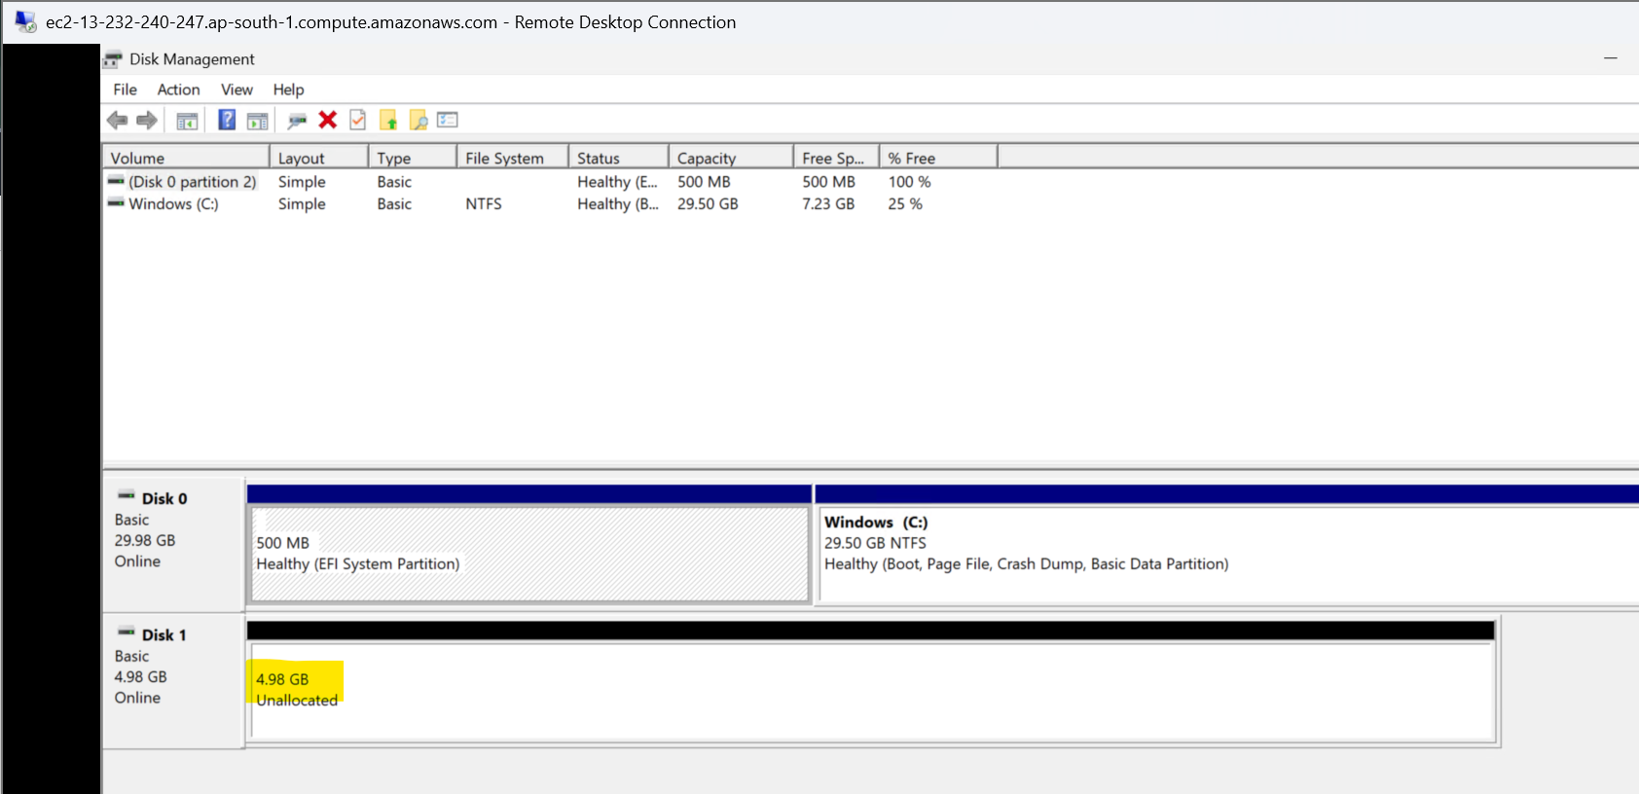
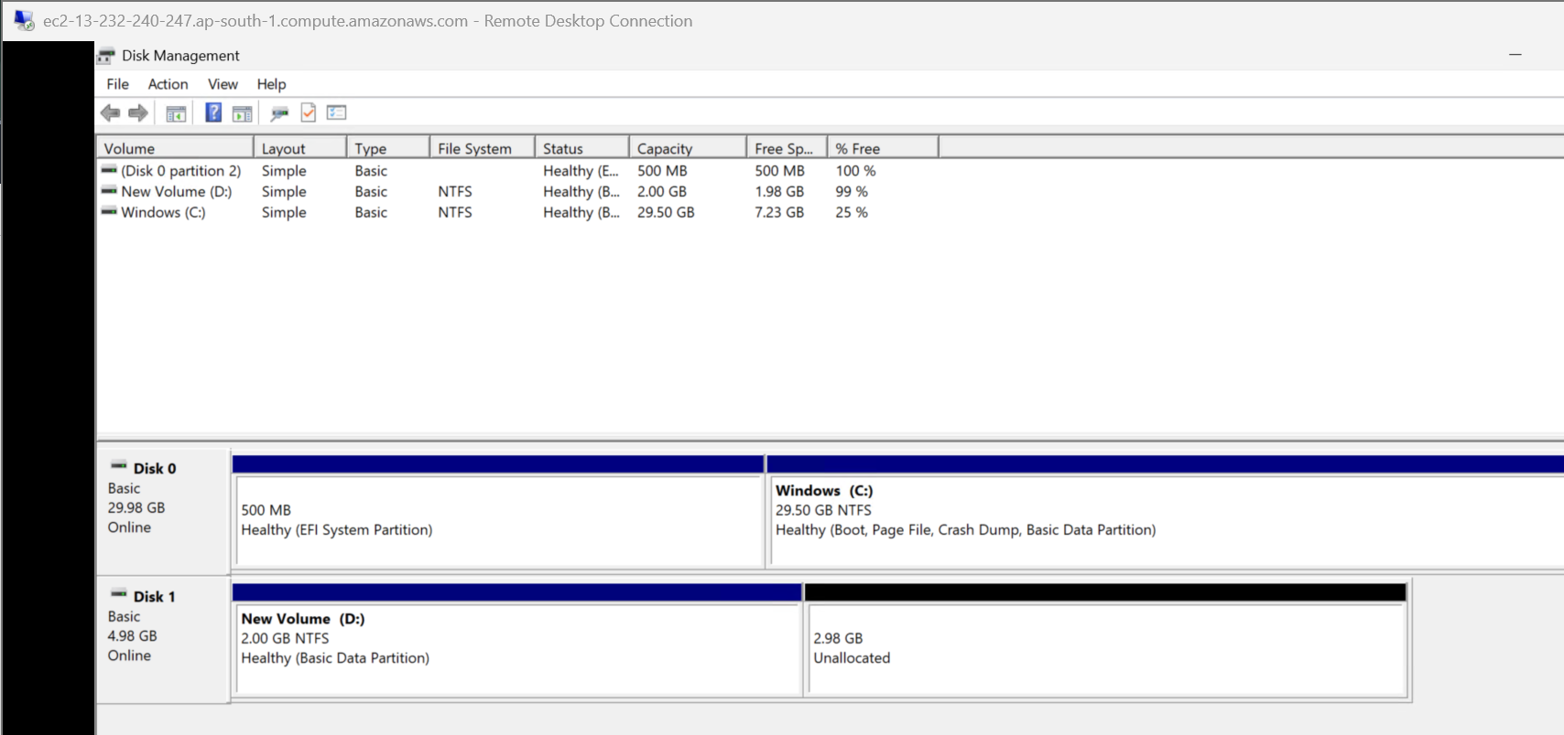
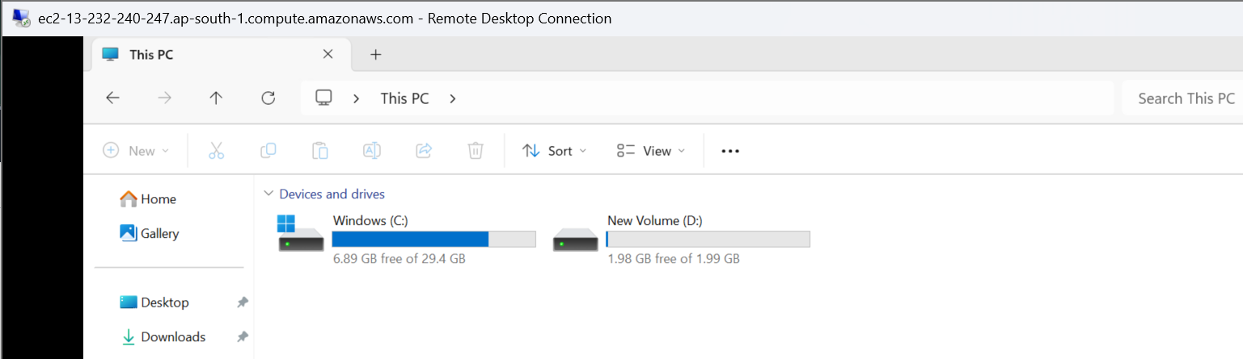
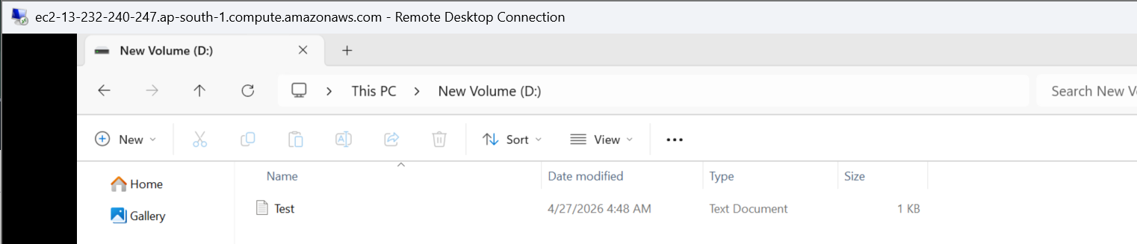
Step 4: Snapshot creation, Verify and data restore from created snapshot
Create the Snapshot:
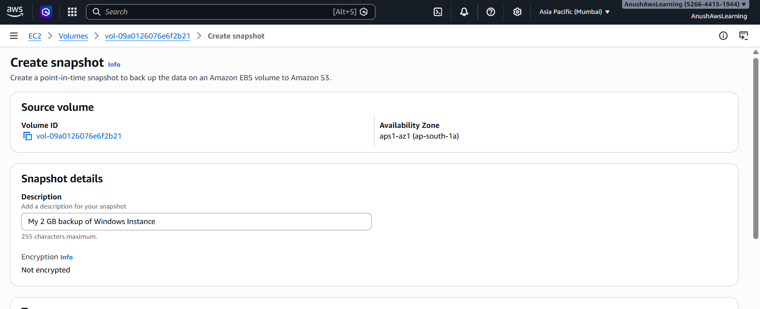

Verify the Snapshot:
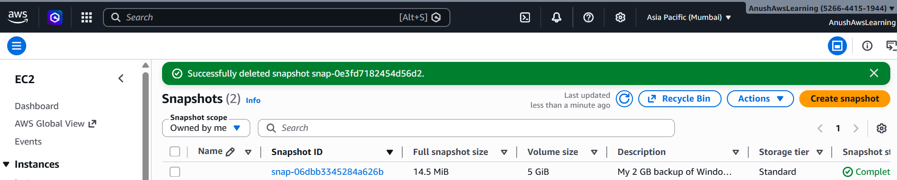

Create a Volume from taken Snapshot:
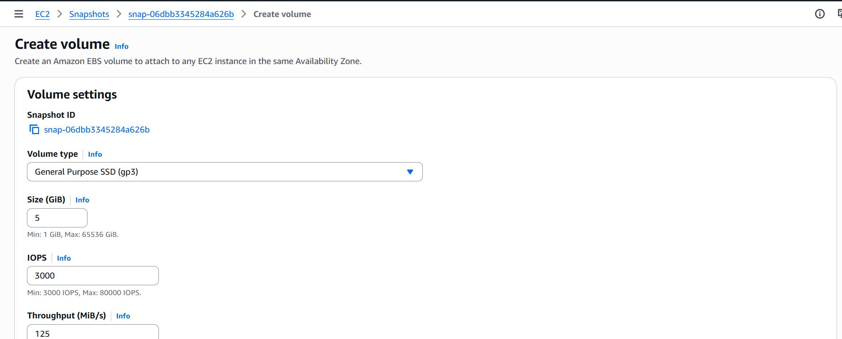
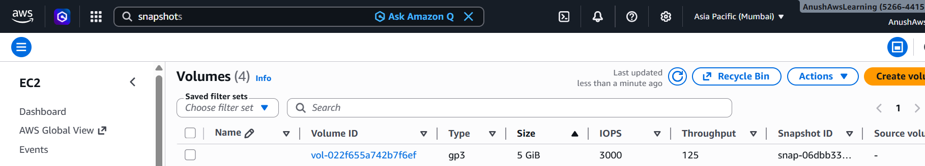

Restore the data with new volume in windows instance:
